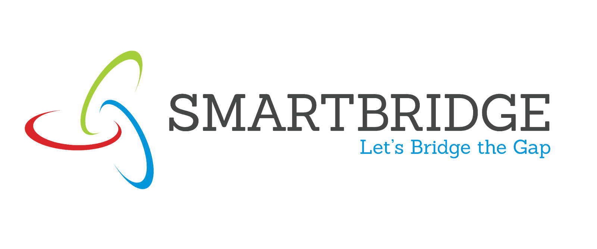
Dashboard Design

Date | 16 August 2026
Team ID
Project Name | Global AI Adoption in Education: A Comprehensive Global Performance Analysis
Maximum Marks

Activity 1
Description
The global AI adoption in education dashboards have been designed with a professional color scheme (dark green headers with navy blue data backgrounds and light blue accent colors) and clear visual hierarchy, enabling intuitive exploration and immediate insight recognition. The layouts are responsive across multiple screen sizes and devices, ensuring accessibility for desktop, tablet, and mobile users. Interactive filters enable dynamic exploration by Country, Region, Year, and AI Tools, allowing stakeholders to segment data and explore how AI adoption and educational impact patterns differ across specific geographic areas, temporal periods, and preferred technology platforms. The dashboard maintains a consistent design language with clear labeling, logical organization, and visual cues that guide users through the analytical narrative.
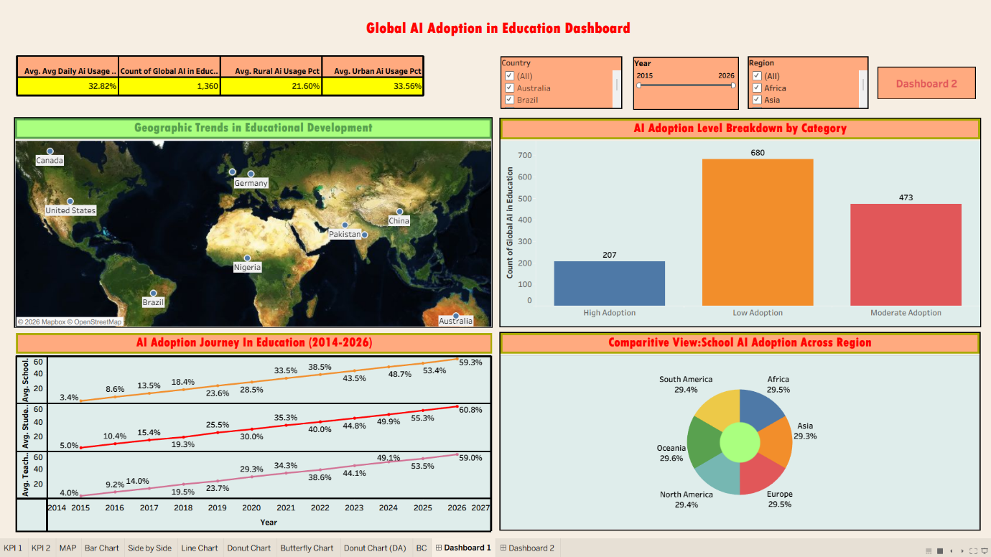
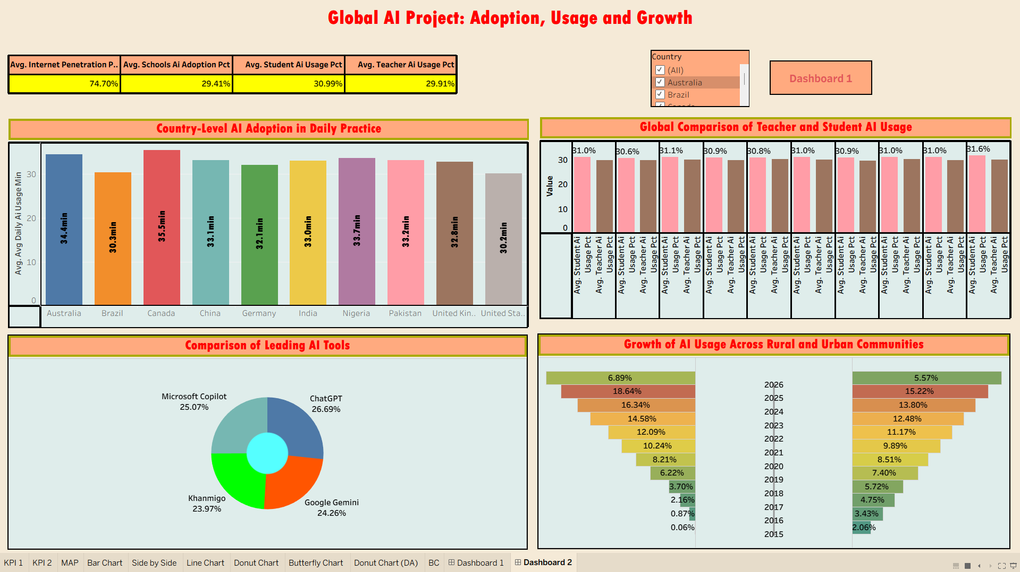

Project Outcomes & Key Insights Report
1. Overview
Two interactive Tableau dashboards were built for this project — “Global AI Adoption in Education Dashboard” and “Global AI Project: Adoption, Usage and Growth” — to analyze how AI is being adopted by students, teachers, and schools across countries and regions from 2015 to 2026. The outcomes below summarize the key metrics, trends, and insights uncovered from both dashboards.
2. Overall KPI Summary
Metric | Value
Average Daily AI Usage (overall) | 32.82%
Total Records Analyzed | 1,360
Average Rural AI Usage | 21.60%
Average Urban AI Usage | 33.56%
Average Internet Penetration | 74.70%
Average School AI Adoption | 29.41%
Average Student AI Usage | 30.99%
Average Teacher AI Usage | 29.91%
Students (30.99%) use AI marginally more than teachers (29.91%), while urban users (33.56%) show notably higher usage than rural users (21.60%) — a gap of about 12 percentage points.
3. AI Adoption Level Segmentation
Adoption Category | Record Count | Share of Total
High Adoption | 207 | 15.2%
Moderate Adoption | 473 | 34.8%
Low Adoption | 680 | 50.0%
Half of all country-year records (50.0%) still fall under “Low Adoption,” indicating that while AI is present almost everywhere, deep integration remains limited in the majority of cases — pointing to significant headroom for growth.
4. Growth Trajectory (2015–2026)
Metric | 2015 | 2026 | Growth
School AI Adoption | 3.4% | 59.3% | ~17.4x
Student AI Usage | 5.0% | 60.8% | ~12.2x
Teacher AI Usage | 4.0% | 59.0% | ~14.8x
School, student, and teacher AI adoption have all grown between 12x and 17x over the eleven-year period, rising in near-parallel trajectories. This indicates coordinated, institution-wide adoption rather than one group (e.g., students) driving growth independently.
5. Regional Distribution of School AI Adoption
Region | Avg. School AI Adoption Share
Oceania | 29.6%
Africa | 29.5%
Europe | 29.5%
North America | 29.4%
South America | 29.4%
Asia | 29.3%
Adoption share is remarkably even across all six regions (29.3%–29.6%), showing that AI adoption in education is a genuinely global trend rather than one concentrated in economically advanced regions.
6. Country-Level Daily Usage Patterns
Country | Avg. Daily AI Usage
Canada | 35.5 min
Australia | 34.4 min
Nigeria | 33.7 min
Pakistan | 33.2 min
China | 33.1 min
India | 33.0 min
United Kingdom | 32.8 min
Germany | 32.1 min
Brazil | 30.3 min
United States | 30.2 min
Daily usage ranges narrowly from 30.2 to 35.5 minutes across the ten countries tracked. Canada and Australia lead in daily engagement, while the United States and Brazil report the lowest — though the overall spread is modest, suggesting consistent day-to-day engagement regardless of a country's development level.
7. Student vs. Teacher AI Usage
Across every country compared, student AI usage (approx. 30.6%–31.6%) consistently runs slightly ahead of teacher usage (approx. 29.9%–31.0%), but the gap stays within about 1 percentage point in each case.
This tight, consistent gap suggests students and teachers are adopting AI tools in parallel, rather than adoption being led predominantly by one group.
8. Leading AI Tools in Education
AI Tool | Share of Usage
ChatGPT | 26.69%
Microsoft Copilot | 25.07%
Google Gemini | 24.26%
Khanmigo | 23.97%
ChatGPT holds a modest lead, but the remaining three tools (Copilot, Gemini, Khanmigo) each retain 24–25% share — indicating a fragmented, multi-tool landscape rather than a single dominant platform.
9. Urban–Rural Divide and Momentum
Overall, urban AI usage (33.56%) exceeds rural usage (21.60%) by roughly 12 percentage points, confirming a clear digital divide. However, the year-by-year growth-share view shows rural communities closing this gap over time: by 2026, rural growth share (6.89%) had edged ahead of urban growth share (5.57%), after starting far behind in 2015 (0.06% vs 2.06%). This suggests rural adoption is now accelerating faster than urban adoption, even though the overall usage level gap has not fully closed yet.
10. Key Outcomes
• AI adoption in education is a genuinely global, near-universal trend (12x–17x growth from 2015–2026) rather than a regionally concentrated phenomenon — regional adoption shares differ by less than 0.5 percentage points.
• Despite strong growth, half of all country-year records remain in the “Low Adoption” category, showing substantial room for deeper integration.
• A persistent but narrowing urban–rural gap (~12 points overall) remains the primary equity concern, though rural growth momentum is now outpacing urban growth.
• Student and teacher adoption are progressing almost in lockstep, suggesting institutional and policy-level support is enabling balanced, coordinated adoption rather than bottom-up, student-only usage.
• No single AI tool dominates the education space — ChatGPT leads narrowly, but Copilot, Gemini, and Khanmigo each hold a meaningful, comparable share.
• Average internet penetration (74.70%) is notably higher than average school AI adoption (29.41%), indicating that connectivity is not the primary bottleneck — institutional readiness and policy are likely bigger constraints.
11. Recommendations (for Dr. Sarah Chen — Educational Technology Director)
• Prioritize rural infrastructure and device access programs to close the ~12-point urban–rural usage gap, building on the rural growth momentum already visible in recent years.
• Target the “Low Adoption” segment (50% of records) with phased, evidence-based deployment frameworks rather than a one-size-fits-all rollout.
• Design joint teacher-student training and change-management programs, since adoption is already progressing in parallel between the two groups.
• Adopt a multi-tool procurement and training strategy (ChatGPT, Copilot, Gemini, Khanmigo) instead of standardizing on a single platform, reflecting the fragmented tool landscape.
• Since regional adoption is already balanced, replicate policies and practices from high-engagement countries (e.g., Canada, Australia) in other regions rather than assuming region-specific barriers.
• Investigate non-connectivity barriers (curriculum integration, teacher training, governance policy) given that internet penetration (74.7%) already outpaces school AI adoption (29.4%) by a wide margin.

Activity 2
Dashboard Public link below:
(DASHBOARD 1 LINK)
https://public.tableau.com/views/GlobalAIAdoptioninEducation_17866941023520/Dashboard1?:language=en-US&:sid=&:redirect=auth&:display_count=n&:origin=viz_share_link
(DASHBOARD 2 LINK)
https://public.tableau.com/views/GlobalAIAdoptioninEducation_17866941023520/Dashboard2?:language=en-US&:sid=&:redirect=auth&:display_count=n&:origin=viz_share_link

